Lab 6 Report

Problems Encountered:

I was originally under the impression that the depth first search would pass over values in some cases. For example, if the first vertex wasn’t connected to the second vertex, the second vertex would never be checked. I wrote a method to counteract this, but after some discussion, it was determined that the depth first search should be able to take care of this anomaly by checking every vertex every time. After implementing this, I still get correct output.

I’ve attached the hand drawn report on the second page of this one.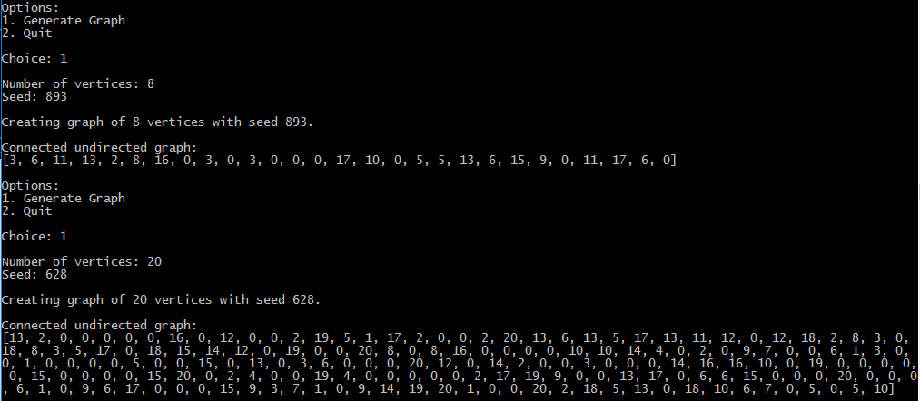 Sorry if it’s a bit hard to read, I used big circles for the vertices and half circles to show which edge belongs to which line.

